[](https://www.google.com/url?sa=i&url=http%3A%2F%2Fkleurplaten.8a8.co%2Findex.php%3Fcodigo%3D1873&psig=AOvVaw0l49_38MabyVE1mrzQDDae&ust=1589286491447000&source=images&cd=vfe&ved=0CAIQjRxqFwoTCLCOm4Doq-kCFQAAAAAdAAAAABAN)[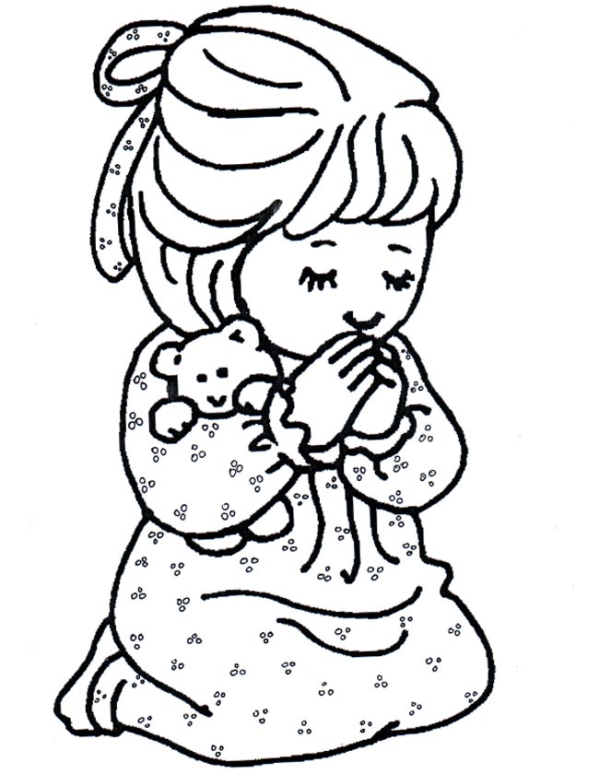](https://www.google.com/url?sa=i&url=https%3A%2F%2Fkleuren.nu%2Fkleurplaat%2Feen-biddend-meisje%2F&psig=AOvVaw0l49_38MabyVE1mrzQDDae&ust=1589286491447000&source=images&cd=vfe&ved=0CAIQjRxqFwoTCLCOm4Doq-kCFQAAAAAdAAAAABAG)