[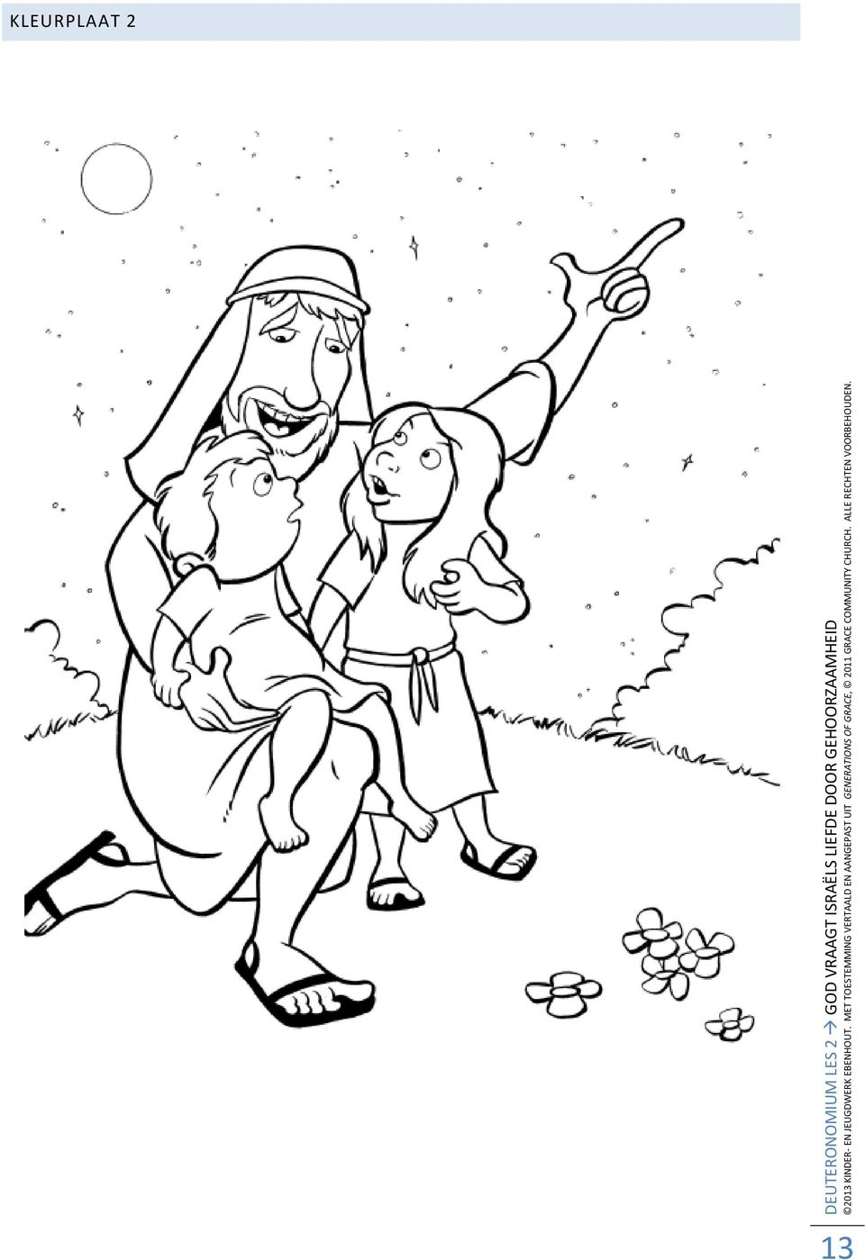](https://www.google.com/url?sa=i&url=https%3A%2F%2Fdocplayer.nl%2F13465964-Gij-zult-de-here-uw-god-liefhebben-met-geheel-uw-hart-en-met-geheel-uw-ziel-en-met-geheel-uw-kracht.html&psig=AOvVaw1eSw26Hgq7UvgOzIhxg33c&ust=1591192598481000&source=images&cd=vfe&ved=0CAIQjRxqFwoTCMCoqdqk4-kCFQAAAAAdAAAAABAk)